SCHOOL OF COMPUTING AND INFORMATICS
DEPARTMENT OF INFORMATION TECHNOLOGY

Name: ALLAN MWAURA
Reg: BSCCS/2024/59744
Repo: https://github.com/spookey01/CRYPT.git
Lecturer: Michael Nyoro

This project is submitted in partial fulfillment of requirement for the Mount Kenya University award of
BACHELOR OF SCIENCE IN COMPUTER SCIENCE
MAY/AUG 2026

Table of Contents
WEEK 1: INTRODUCTION TO ADVANCED CRYPTOGRAPHY 2
Encrypt “SECURITY” using Caesar Cipher with shift 4. 2
Weakness Identification 3
Caesar Cipher Weaknesses 3
Vigenère Cipher Weaknesses 4
WEEK 2: STREAM CIPHERS AND PSEUDORANDOMNESS 5
Python Random Numbers 5
Linear Congruential Generator 6

WEEK 1: INTRODUCTION TO ADVANCED CRYPTOGRAPHY

Encrypt “SECURITY” using Caesar Cipher with shift 4.
Encrypted text: WIGYVMXC
- Encrypt “NETWORK” using Vigenère Cipher using keyword “KEY”.
Encrypted text: XIRGSPU
- Exchange encrypted messages and attempt decryption.
Encrypted message: YMNX NX F YJXY
- Cipher used: Caesar Cipher (Shift = 5)
- Recovered plaintext: THIS IS A TEST
Feature | Caesar Cipher | Vigenère Cipher
Method | Fixed shift | Keyword-based shifts
Key | Single number | Word/phrase
Security | Weak | Moderate
Advantages | Simple, fast | More secure
Weaknesses | Easily cracked | More complex
Implementation | Very easy | Moderate


Screenshot of an online classical cipher simulation

Weakness Identification

Caesar Cipher Weaknesses
- Only 25 possible keys → easy brute force
- Preserves letter patterns
- Very easy frequency analysis attack
- Not secure at all in modern cryptography

Vigenère Cipher Weaknesses
- Repeating keyword creates pattern repetition
- Can be broken using:
  - Frequency analysis
  - Kasiski examination (key length detection)
- Weak if keyword is short or simple

WEEK 2: STREAM CIPHERS AND PSEUDORANDOMNESS

Python Random Numbers
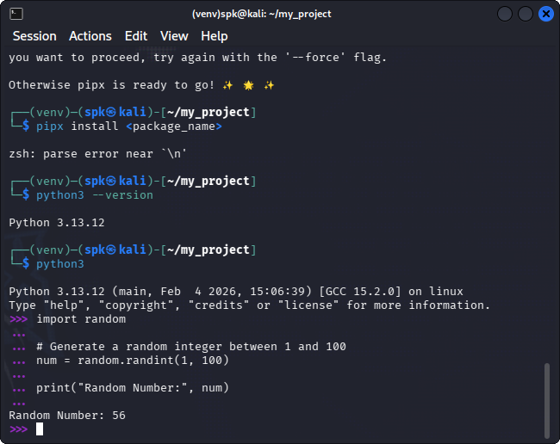

Linear Congruential Generator
